**A PROJECT REPORT**

**on**

## **“Bird Species Image classification”**



**Submitted to**

## **KIIT Deemed to be University**

**In Partial Fulfillment of the Requirement for the Award of BACHELOR’S DEGREE IN**

**COMPUTER SCIENCE AND SYSTEM ENGINEERING**

**BY**

**Omkar Vatsa**

|  |  |
| --- | --- |
|  |  |
|  |  |

**SCHOOL OF COMPUTER ENGINEERING**

**KALINGA INSTITUTE OF INDUSTRIAL TECHNOLOGY**

**BHUBANESWAR, ODISHA - 751024**

**April 2022**

|  |  |
| --- | --- |
|  |  |
|  |  |

# 

ACKNOWLEDGEMENTS

We feel immense pleasure and feel privileged in expressing our deepest and most

sincere gratitude to our supervisor **DR. Hrudya kumar tripathy** for his excellent guidance throughout our project work. His kindness, dedication, hard work and attention to detail have been a great inspiration to us. Our heart felt thanks to you sir for the unlimited support and patience shown to us. We would particularly like to thank him for all his help in patiently and carefully correcting all our manuscripts.

We are also very thankful to all our faculty members coordinating the B.Tech

projects for our discipline, for their support and suggestions during our course of the project work in the final year of our undergraduate course.

1.INTRODUCTION

Bird species identification is a challenging task that often results in obscure labels. Even expert bird watchers sometimes disagree with the species given the image of a bird. It is a serious problem that pushes the limits of the visual skills of both people and computers. Although different bird species share the same basic set of components, different bird species may differ significantly in shape and appearance. Intraclass variations are high due to light and background variations as well as extreme standing variations (e.g., flying birds, swimming birds, and permanent birds with slightly closed branches).

Our project aims to use electronic learning capabilities to help beginner as well as experienced bird watchers and enthusiasts to identify the species of birds in their photographs.

|  |  |
| --- | --- |
|  |  |
|  |  |

|  |  |
| --- | --- |
|  |  |
|  |  |

# **Chapter 2**

Basic Concepts/ Literature Review

Data set of 400 bird species.58388 training images, 2000 test images(5 images per species) and 2000 validation images(5 images per species. All images are 224 X 224 X 3 color images in jpg format

In particular, it was discovered that ecologists monitor them to determine the factors causing population fluctuation and to help in conserving and managing threatened and endangered species. The various surveys used in counting bird species including data collection techniques were succinctly reviewed. It was established that a small but growing number of researchers have studied the use of computer vision for monitoring

species of birds.

This chapter evaluates reports of studies found in literature that are related to monitoring and classification of species. In particular, it focuses on reviewing bird techniques used for these species are often similar, and motion features which this research seeks to investigate for classification of birds. First techniques which perform classification using single images were explored. This was done by reviewing them separately as those that are used for classification of bird species.

**Chapter 3**

Problem Statement / Requirement Specifications

Machine learning is the most popular technique of predicting or classifying information to help people in making necessary decisions .machine learning algorithms are trained over instances or example through which they learnt from past experiences and analyze the historical data.as it trains over the example,again and again,it is able to identify patterns in order to make decision more accurately .whenever any new input is introduced to the ML model ,it applies its learned pattern over the new data to make future predictions.based on the final accuracy ,one can optimize their models using various standardized approaches.in this way, machine learning model learns to adopt to new examples and produce better results.now we collect the data from the drives

Collect the data :-

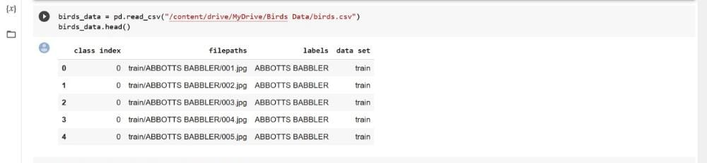

**Block Diagram**

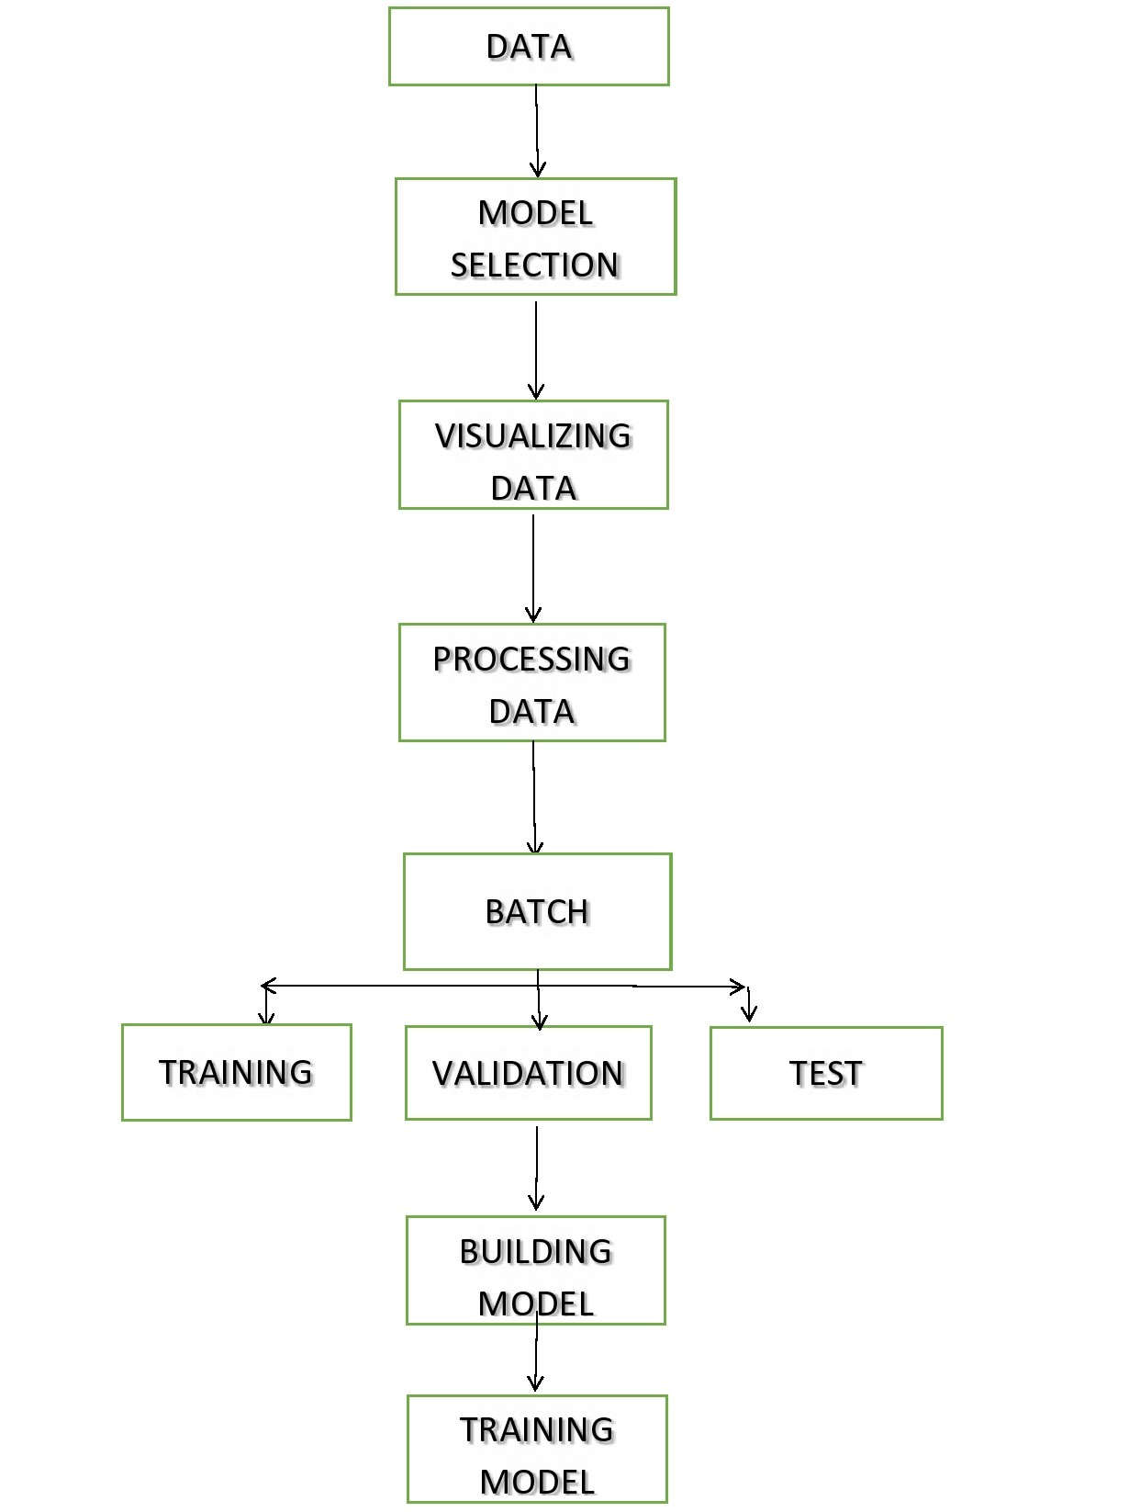

Chapter 4

Implementation

In this section, we present the implementation done by our team during the project development.

#### **4.1 Methodology**

This subsection contain the steps we have followed and the machine learning algorithm implemented to complete the project.

**1. Problem Statement Definition**

In this project our goal is to identify the species to which a bird belongs to among the 400 different species that our model was trained on and classify it accordingly.

**2. Data Definition**

Data set of 400 bird species.58388 training images, 2000 test images(5 images per species) and 2000 validation images(5 images per species. All images are 224 X 224 X 3 color images in jpg format.

Data::<https://www.kaggle.com/gpiosenka/100-bird-species?select=EfficientNetB4-BIRDS-0.99.h5>

**3. ML Model Selection**

In our project we will be using the following model from TensorFlow Hub.

efficientnet/b4/classification Imagenet (ILSVRC-2012-CLS) classification with EfficientNet-B4.

Model_URL: <https://tfhub.dev/tensorflow/efficientnet/b4/classification/1>

**4. Data Cleaning / Preparation**

We check for any missing values in our dataset. Then, we create file paths for every image present in our dataset to be used in our ML model to access the images. We also create Boolean Labels for our ML model to train and make predictions.

**5. Data Visualization**

We create a function that takes the list of file paths, the starting index, the ending index and displays all the images present in that range along with their labels so we can better understand the data we are working with.

**6. Data Processing**

We resize all our images into the shape of 224 X 224 X 3 and normalize them for faster processing and more accurate predictions. We then create define a function that takes our file paths as input and convert the images into tensors.

**7. Batch Creation**

In our project we decided to create batches of size 32. Hence, we define a function that create different batches for our training, validation and test datasets.

**8. Batch Visualization**

After successfully creating batches of our images, we define a function to display all the images present in a batch.

**9. Building Model**

Once we are done working with our data, we start building our model. We create our model using the Keras Sequential API. For our model, we choose the Adam Optimizer as our Optimizer, Categorical Cross Entropy as our loss function and Accuracy as our metric for evaluation. We also use the Early Stopping and TensorBoard callback in our model.

**10. Training Model**

After building the model, we start training our model on the training batches we created earlier.

**11. Model Predictions**

Once the model is successfully trained, we start making prediction on our test batches we created earlier.

**12. Prediction Visualization**

#### We define a function that takes our test batch as input, make prediction on the test batch, unbatches the batch and plot the top 10 **4.3 Result Analysis OR Screenshots**

In this subsection, the final output of our project and some graphs, plots are presented.

predictions for each image in the batch.

**Sample count of each species**

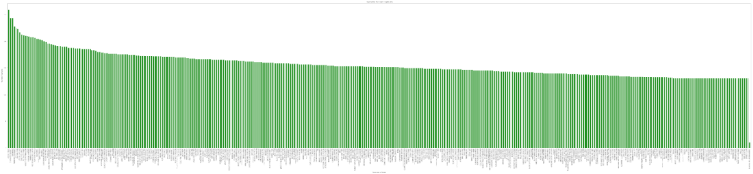

#### **Visualization of a training batch**

#### 

**Model Prediction on single image**

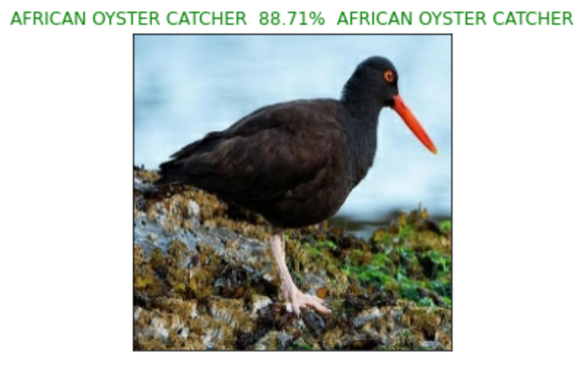

**Top 10 Predictions on test batch**

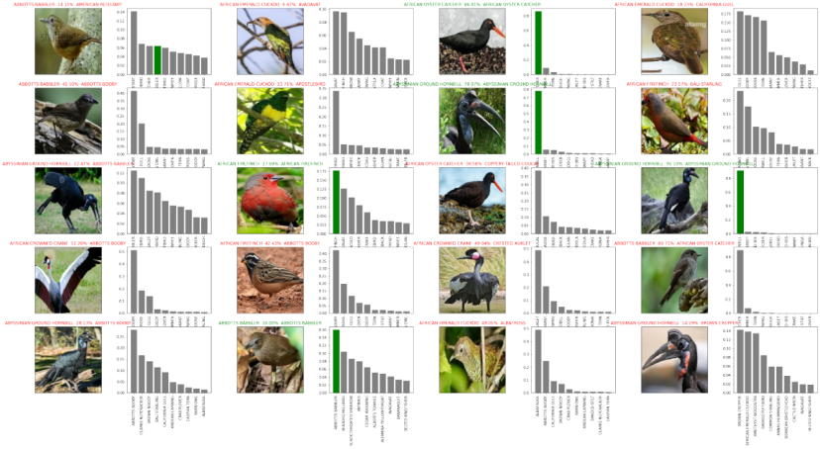

|  |  |
| --- | --- |
|  | **CHAPTER 6**  Conclusion and Future Scope  **6.1 Conclusion**  In This Project we have created a machine learning model which was trained on a batch of 20,000 images of Birds through which we have got the prediction accuracy of 70%.  This project has helped us in understanding concepts of supervised and transfer learning and how to work with unstructured data. We have optimized our model using various parameters. |
|  |  |
|  |  |

6.2 FUTURE SCOPE

The future Scope of our project can be these :-

1. To improve our Model accuracy by increasing the sample size of our dataset which was 20,000 or by using the full dataset of 63,604 images.

2. By Deploying our machine learning model through an android Based Application .

|  |  |
| --- | --- |
|  |  |
|  |  |

**INDIVIDUAL CONTRIBUTION REPORT:-**

**Bird Species - Image Classification using ML**

ALOK KUMAR

1928009

**Abstract:** Our project aims to use electronic learning capabilities to help beginner as well as experienced bird watchers and enthusiasts to identify the species of birds in their photographs.

**Individual contribution and findings:** The area of interest and the project topic was

decided upon by me as well as collection of the data for the project and visualizing of the data of

the project. Assignment of tasks to individual members were also part of my responsibilities. I

extensively worked on collection and visualizing of data . i created as well as making and

visualizing predictions on testing batches of images..

**Individual contribution to project report preparation:** During the preparation

of our report i worked in writing the introduction ,basic concept ,requirement specification and

the block diagram (ie.Chapter 3) in this report as well as provide the references and resources we

used while working on our project.

**Individual contribution for project presentation and demonstration:**

Demonstrated the topic of bird species image classification in the project.

Full Signature of Supervisor: Full signature of the student:

……………………………. ……………………………..

**Bird Species - Image Classification using ML**

RISHAV KUMAR RATHOUR

1928049

**Abstract:** Our project aims to use electronic learning capabilities to help beginner as well as experienced bird watchers and enthusiasts to identify the species of birds in their photographs.

**Individual contribution and findings:** My topic of Contribution was on Data preprocessing which is the most essential factor contributing to this Project . I insisted on choosing Birds 400 - Species Image Classification As a result our Model was able to achieve high accuracy. My part was to resize the images and convert them into tensor flow data .

**Individual contribution to project report preparation:** During the preparation of our report i worked in writing the Conclusion and future Scope of our project (ie. Chapter 6) in this report as well as provide the references and resources we used while working on our project.

**Individual contribution for project presentation and demonstration:**  I am responsible for doing the date preprocessing part so any question related to it shall be answered by me during the project presentation .

Full Signature of Supervisor: Full signature of the student:

……………………………. ……………………………..

**Bird Species - Image Classification using ML**

OMKAR VATSA

1928042

**Abstract:** Our project aims to use electronic learning capabilities to help beginner as well as experienced bird watchers and enthusiasts to identify the species of birds in their photographs.

**Individual contribution and findings:** The area of interest and the project topic was decided upon by me as well as sourcing of the data for the project and planning and implementation of the project as well as the division of workload among members as well as training and assignment of tasks to individual members were also part of my responsibilities. I extensively worked on building our machine learning model, training the model on batches of processed images i created as well as making and visualizing predictions on testing batches of images.

**Individual contribution to project report preparation:** During the preparation of our report i worked in writing the methodology followed and the implementation of our project (ie. Chapter 4) in this report as well as provide the references and resources we used while working on our project

**Individual contribution for project presentation and demonstration:** I extensively worked on the working and implementation of our project and was in charge of giving the demonstration and explaining our project as well as taking any questions regarding the same during the presentation of this project.

Full Signature of Supervisor: Full signature of the student:

……………………………. ……………………………..

**Bird Species - Image Classification using ML**

RINTU PATRA

1928048

**Abstract:** Our project aims to use electronic learning capabilities to help beginner as well as experienced bird watchers and enthusiasts to identify the species of birds in their photographs.

**Individual contribution and findings:** I have Contributed in the data preparation part.

**Individual contribution to project report preparation:**  I had worked on data preparation for this project.

**Individual contribution for project presentation and demonstration:** I am responsible for answering questions related to data preparation in my presentation time.

Full Signature of Supervisor: Full signature of the student:

……………………………. ……………………………..

*References:-*

*1. <https://www.tensorflow.org/api_docs/python/tf/all_symbols>*

*2. <https://www.tensorflow.org/hub>*

*3.<https://proceedings.mlr.press/v123/kim20a.html>*

*4.https://towardsdatascience.com/a-comprehensive-guide-to-convolutional-neural-networks-the-eli5-way-3bd2b1164a53?gi=ccf95b86c812*

|  |  |
| --- | --- |
|  |  |
|  |  |

|  |  |
| --- | --- |
|  |  |
|  |  |

**Plagiarism Report:-**



    
    
    
    

    
    
    
    